DELIVERABLE 4: ANALYSIS
Solar Energy Potential Analysis Across Alberta
CWEEDS Historical Weather Data + SAIT Campus Solar Dataset

Final Verified Analytical Solution Documentation
SAIT Data Analytics Capstone | 2026
Prepared for Capstone
Aduaka Samuel Chidubem, Prutha Ketan Chokshi, Abiola Abosede Abioye
Southern Alberta Institute of Technology (SAIT)

Verification basis
This report was reconciled against the submitted Python notebooks (01–07), final analytical CSV exports, the current Power BI .pbix report, Deliverables 1–3, and the capstone presentation. Numerical results are reported from the executed notebooks/exports; proposal-only items are explicitly identified as changes rather than presented as completed work.

Client framing used by the project: Alberta Utilities Commission (AUC)

Table of Contents
Section | Topic
1 | Project Overview and Problem
2 | Final Solution and Power BI Product
3 | Data Sources, Model and Dictionary
4 | Cleaning and Quality Assurance
5 | Exploratory Analysis
6 | Feature Engineering and Machine Learning
7 | PV Optimization, Payback and Trends
8 | SAIT Validation Assessment
9 | Results Against Proposal Objectives
10 | Changes from Proposal
11 | Risk/Reward, Limitations and Reproducibility
12 | References

Executive Summary
This capstone transforms long-term Alberta meteorological data and real SAIT campus solar measurements into a practical solar-analysis framework. The verified solution compares four Alberta cities, predicts hourly Global Horizontal Irradiance (GHI), optimizes fixed panel tilt, estimates annual PV generation and simple payback, tests long-term GHI trends, and communicates results through Power BI. The project’s original stakeholder framing was to translate raw weather data into decision-ready evidence for the AUC, municipalities, solar developers, and Alberta households/businesses [P1][P2].
The final workflow cleaned 701,280 CWEEDS hourly records (1998–2017) and 1,048,575 raw SAIT rows, retaining 13,423 complete SAIT solar hours. The selected Random Forest achieved test R² = 0.9169, MAE = 36.59 Wh/m² and RMSE = 69.54 Wh/m². Optimized fixed tilt ranged from 39° to 42°, base simple payback ranged from 13.23 to 14.52 years, and Edmonton was the only city with a statistically significant increasing GHI trend. Direct SAIT timestamp validation was impossible because the supplied CWEEDS series ends in 2017 while usable complete SAIT hours begin in 2019; the replacement climatological consistency check produced Pearson r = 0.9686.
Critical coverage correction
Earlier planning documents assumed 22 years of CWEEDS data through 2020. The actual four station files used in Python contain 20 years, 1998–2017. The final analysis uses only those verified records and does not fabricate an overlap period.

1. Project Overview and Problem

1.1 Problem statement
The project addresses a practical interpretation gap: Alberta has strong but geographically and seasonally variable solar resources, while raw hourly engineering-weather records are not directly usable by non-technical decision makers. The analytical need is therefore to convert station-level irradiance and weather data into city comparisons, predictive evidence, installation-oriented yield estimates, financial sensitivity ranges, and long-term trend information. This is consistent with the mission and stakeholder analysis established in Deliverables 1–3 [P1][P2][P3].

1.2 Final analytical questions
- How do GHI and related solar-resource measures differ across Calgary, Edmonton, Lethbridge and Medicine Hat?
- Can hourly GHI be predicted from geography, meteorology and cyclical time information with out-of-sample R² ≥ 0.85?
- What fixed panel tilt maximizes annual plane-of-array irradiance, and what annual energy/payback follows for 10 kWp and 100 kWp systems?
- Do annual GHI records show statistically significant trends from 1998–2017?
- Do historical Calgary solar patterns remain consistent with the real SAIT campus generation profile, given the available data coverage?

2. Final Solution and Product
The final solution consists of seven Python notebooks, a set of processed CSV outputs, and a four-page Power BI report. Python performs all cleaning, EDA, feature engineering, modeling, statistical testing, PV simulation and export preparation. Power BI consumes the pre-aggregated outputs for stakeholder-facing exploration.
Power BI page (verified) | Main verified content
City Comparisons | City GHI cards, Year slicer, city comparison bar chart, yearly GHI line chart
Seasonal heatmap | Month-by-city matrix/heatmap and monthly GHI line chart
Optimization & Payback | PV-yield table, payback scenario matrix/slicer, best/base/worst payback chart
Trends & Sait | Trend table/slope card and normalized historical GHI vs SAIT PV profile chart

3. Data Sources and Analytical Model

3.1 Verified data coverage
Dataset | Raw/verified coverage | Rows used | Final role
CWEEDS - 4 Alberta stations | 1998-01-01 to 2017-12-31 23:00 | 175,320/city; 701,280 combined | EDA, ML, tilt/POA, trends
SAIT campus solar | raw starts 2018-04-08; complete usable hours 2019-03-08 to 2023-09-19 | 1,048,575 raw; 13,423 complete hours | Campus EDA + climatological consistency check

The SAIT file contains Carport Solar, Rooftop Solar and GBT Consumption fields. The analysis uses the two solar channels for the validated solar workflow. CWEEDS provides hourly irradiance and meteorological variables for the four selected stations [R1][R7].

3.2 Verified Power BI semantic-model structure
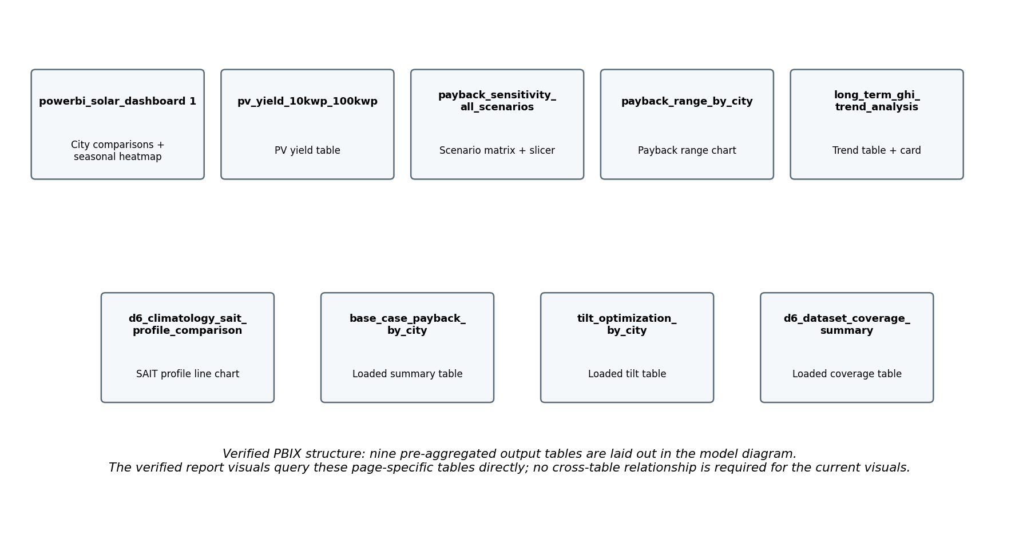
Figure 1. Table structure extracted from the submitted Power BI .pbix DiagramLayout.
The submitted PBIX contains nine pre-aggregated analytical tables in its model diagram. The current visuals query page-specific tables directly. This is a deliberate reporting model rather than a star schema: the tables have different grains (city-year-month-hour, city-level optimization, scenario-level payback, month-hour SAIT profile) and do not need to be merged into a single fact table for the verified visuals.

3.3 Data Dictionary - Fields Used in the Final Solution
Field | Type | Source | Description
timestamp | datetime | CWEEDS/SAIT | Observation time; coverage, hourly aggregation and chronological ML split
city | text | CWEEDS | Calgary, Edmonton, Lethbridge or Medicine Hat
latitude / longitude | decimal | CWEEDS metadata | Station coordinates used as ML/geographic inputs and solar geometry
elevation_m | decimal | CWEEDS metadata | Station elevation in metres
ghi_wh_m2 | decimal | CWEEDS | Hourly Global Horizontal Irradiance; final ML target
dni_wh_m2 | decimal | CWEEDS | Direct Normal Irradiance; EDA and POA simulation, not final ML predictor
dhi_wh_m2 | decimal | CWEEDS | Diffuse Horizontal Irradiance; EDA and POA simulation, not final ML predictor
dry_bulb_temp_c | decimal | CWEEDS | Air temperature; final ML predictor
dew_point_temp_c | decimal | CWEEDS | Dew point; final ML predictor
wind_speed_ms | decimal | CWEEDS | Wind speed; final ML predictor
station_pressure_pa | numeric | CWEEDS | Station pressure; final ML predictor
year / month / hour / day_of_year | integer | derived | Calendar grouping and time-cycle construction
hour_sin / hour_cos | decimal | derived | Cyclical hour-of-day features
doy_sin / doy_cos | decimal | derived | Cyclical annual-position features
city_* | binary | derived | One-hot city indicators for ML
carport_hourly_wh | decimal | SAIT derived | Cleaned hourly Carport solar mean from complete minute observations
rooftop_hourly_wh | decimal | SAIT derived | Cleaned hourly Rooftop solar mean
total_hourly_wh | decimal | SAIT derived | Combined hourly Carport + Rooftop solar value
total_observations | integer | SAIT derived | Underlying valid solar observation count per hour
quality_flag | category | SAIT derived | complete / partial / missing
Annual_POA_kWh_m2 | decimal | PV output | Annual plane-of-array resource at optimized tilt
Residential_10kWp_kWh | decimal | PV output | Estimated annual 10 kWp generation using PR = 0.80
Industrial_100kWp_kWh | decimal | PV output | Estimated annual 100 kWp generation using PR = 0.80
Residential_Payback_Years | decimal | financial | Simple payback under the selected scenario

4. Data Cleaning and Quality Assurance

4.1 CWEEDS workflow
- Parsed the four selected station files, extracted station metadata, standardized column names and converted timestamps.
- Converted the selected irradiance and weather variables into analysis units: GHI/DNI/DHI in Wh/m², temperature in °C, wind in m/s and pressure in Pa.
- Checked the hourly sequence for every station: exactly 175,320 records per city, zero duplicate timestamps and zero missing hours in the supplied 1998–2017 files.
- Inspected quality flags/coded missing values before modeling; highly incomplete variables were not forced into the final feature set.
- Final physical-range audit returned zero negative GHI/DNI/DHI values and zero invalid sunshine >60, sky cover >10, wind direction >360 or invalid snow-cover values.

4.2 SAIT workflow
- The raw SAIT file contains 1,048,575 rows and irregular spacing: dominant one-minute records plus 15-, 30-, 60-minute intervals and long outages.
- 71,293 negative Carport readings and 27 negative Rooftop readings were clipped to zero for PV-generation analysis; correction counts were retained.
- Raw solar readings were grouped hourly and the number of valid underlying observations was counted separately for each hour.
- An hour is classified complete only when the total solar observation count equals 60; partial hours contain 1–59 observations.
SAIT hourly quality | Hours | Use
Complete (count = 60) | 13,423 | Primary SAIT analysis
Partial (1–59) | 39 | Quality documentation only
Missing / no solar | 34,306 | Not used as valid generation
Total hourly frame | 47,768 | Coverage audit

Quality-control decision
The analysis does not blanket-exclude 2021 or 2022. Instead, it uses only complete hours wherever they exist. Verified complete-hour counts include 928 hours in 2021 and 1,426 in 2022. This is more precise than treating whole years as equivalent or unusable.

5. Exploratory Data Analysis
City | Mean GHI | Mean DNI | Mean DHI | Mean temp °C | Mean wind m/s
Calgary | 150.77 | 187.67 | 59.22 | 4.84 | 3.89
Edmonton | 142.57 | 174.09 | 58.73 | 2.85 | 3.55
Lethbridge | 159.28 | 196.52 | 58.69 | 6.76 | 4.48
Medicine Hat | 157.29 | 191.35 | 59.27 | 6.26 | 3.68

- Lethbridge had the highest all-hour mean GHI at 159.28 Wh/m², followed by Medicine Hat (157.29), Calgary (150.77) and Edmonton (142.57). Relative to Edmonton, mean GHI was 11.72% higher in Lethbridge, 10.32% higher in Medicine Hat and 5.75% higher in Calgary.
- All cities show strong seasonality: winter is lowest, spring rises sharply and summer is highest. The average hourly GHI profile peaks around 12:00 for all four cities.
- Peak-hour mean GHI was 473.33 Wh/m² in Calgary, 442.55 in Edmonton, 501.33 in Lethbridge and 494.54 in Medicine Hat.
- Combined correlations with GHI were strongest for DNI (~0.845) and DHI (~0.710); dry-bulb temperature was moderate (~0.497), while dew point, wind and pressure were weaker linear correlates.
- SAIT complete-hour solar generation follows the expected daily and seasonal curve, with the mean daily combined profile peaking around 13:00.
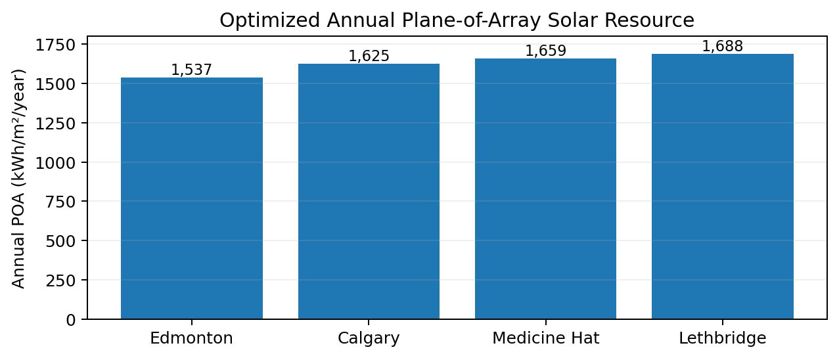
Figure 2. Sample final output: optimized annual plane-of-array solar resource by city.
The optimized POA result preserves the city ranking used in the final presentation: Lethbridge 1,687.64 kWh/m²/year, Medicine Hat 1,659.30, Calgary 1,624.91 and Edmonton 1,537.00.

6. Feature Engineering and Machine Learning

6.1 Final model design
Feature group | Final verified features
Geography | latitude, longitude, elevation_m
Meteorology | dry_bulb_temp_c, dew_point_temp_c, wind_speed_ms, station_pressure_pa
Daily cycle | hour_sin, hour_cos
Annual cycle | doy_sin, doy_cos
City indicators | city_Calgary, city_Edmonton, city_Lethbridge, city_Medicine Hat

The final target is hourly GHI (`ghi_wh_m2`). Same-hour DNI and DHI are intentionally excluded from the model feature set even though they are strongly correlated with GHI. This prevents the model from becoming an overly direct reconstruction of the target and keeps the prediction based on location, meteorology and time-cycle information.

6.2 Chronological train / validation / test split
Split | Years | Rows | Share
Train | 1998–2011 | 490,848 | 70%
Validation | 2012–2014 | 105,216 | 15%
Test | 2015–2017 | 105,216 | 15%

The split is chronological rather than random to reduce temporal leakage. Each city contributes 122,712 training rows and 26,304 rows to each validation/test period.

6.3 Baseline, tuning and final performance
Model / period | R² | MAE | RMSE
Linear Regression / validation | 0.6953 | 100.7220 | 129.0732
RF_A / validation | 0.8998 | 38.7750 | 74.0207
RF_B / validation - selected | 0.9006 | 38.0272 | 73.7001
RF_C / validation | 0.9005 | 37.9536 | 73.7608
RF_B / untouched test | 0.9169 | 36.5911 | 69.5430

RF_B used 150 trees, maximum depth 25, minimum leaf size 3, square-root feature sampling, parallel processing and random_state=42. It was selected on the validation set because it produced the lowest validation RMSE; the test period was evaluated only after model selection.

6.4 Model Evaluation and Interpretation
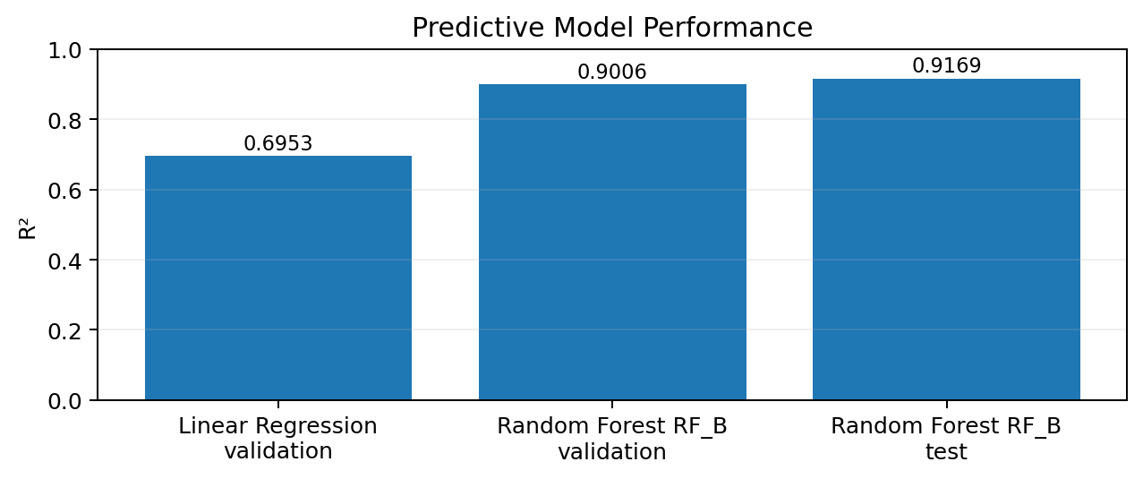
Figure 3. Verified model R² from the executed modeling notebook.
City | Test R² | MAE | RMSE
Calgary | 0.9047 | 38.9873 | 73.7264
Edmonton | 0.9174 | 34.3241 | 65.5330
Lethbridge | 0.9222 | 36.7826 | 69.8574
Medicine Hat | 0.9220 | 36.2705 | 68.8091

All four cities exceeded R² = 0.90, so the aggregate score is not driven by a single station. The final model exceeded the proposal target of R² ≥ 0.85 [P2].
Rank | Feature | Importance
1 | hour_cos | 0.5034
2 | dry_bulb_temp_c | 0.2249
3 | doy_cos | 0.0903
4 | hour_sin | 0.0518
5 | dew_point_temp_c | 0.0471
6 | doy_sin | 0.0450
7 | station_pressure_pa | 0.0169
8 | wind_speed_ms | 0.0148

Important correction from the presentation
The executed final model does not use sunshine minutes, DNI or a clear-sky index as its strongest features. Those items appeared in the presentation, but the actual notebook feature importances are the values shown above. This report follows the executed notebook.

7. PV Optimization, Yield, Payback and Long-Term Trends

7.1 Tilt optimization and PV yield
The `pvlib` workflow calculated solar position for each station and simulated total plane-of-array irradiance for fixed south-facing panels from 20° to 60° in 1° increments. The simulation used cleaned GHI, DNI and DHI, solar zenith/azimuth, an isotropic sky model and ground albedo = 0.20. The yield-maximizing angle was compared with the project benchmark tilt formula from the proposal [P2][R3].
City | Optimized tilt | Annual POA | 10 kWp annual | 100 kWp annual
Calgary | 42° | 1,624.91 | 12,999.28 | 129,992.8
Edmonton | 42° | 1,537.00 | 12,296.00 | 122,960.0
Lethbridge | 40° | 1,687.64 | 13,501.12 | 135,011.2
Medicine Hat | 39° | 1,659.30 | 13,274.40 | 132,744.0

Annual generation uses the verified simplified formula: Annual POA × system capacity × performance ratio, with PR = 0.80. The proposal’s separate −0.40%/°C temperature coefficient was not separately applied in the final sizing notebook.

7.2 Simple payback and sensitivity
City | Best case | Base case | Worst case
Calgary | 9.62 y | 13.74 y | 19.23 y
Edmonton | 10.17 y | 14.52 y | 20.33 y
Lethbridge | 9.26 y | 13.23 y | 18.52 y
Medicine Hat | 9.42 y | 13.45 y | 18.83 y

Base assumptions are $2.50/Wp installed cost and $0.14/kWh electricity value. Sensitivity scenarios use $2.00/Wp + $0.16/kWh (best/low-cost) and $3.00/Wp + $0.12/kWh (worst/high-cost). These low/high inputs are analysis scenarios, not claimed as independently verified market forecasts.

7.3 Long-term GHI trends
City | Slope / decade | Linear p | Mann-Kendall result | MK p
Calgary | 2.4826 | 0.1722 | no trend | 0.1834
Edmonton | 2.9524 | 0.0232 | increasing | 0.0297
Lethbridge | 2.1662 | 0.2007 | no trend | 0.2058
Medicine Hat | 1.5614 | 0.3481 | no trend | 0.2843

All fitted linear slopes are positive, but only Edmonton is statistically significant under both tests (linear p = 0.0232; Mann-Kendall p = 0.0297). The verified Edmonton linear slope is +2.9524 Wh/m² per decade in annual mean hourly GHI, as reported by the notebook trend table; this report does not substitute the different slope values shown on the presentation trend slide.

8. SAIT Real-World Validation Assessment

8.1 Intended method vs available data
The proposal planned timestamp-aligned Calgary weather/model predictions against SAIT measured generation and an empirical performance-ratio comparison [P2][P3]. The actual supplied coverage blocks that test: Calgary CWEEDS ends 2017-12-31, while the verified complete SAIT solar series begins 2019-03-08. No direct timestamp overlap exists.
Dataset | Start | End | Rows
Calgary CWEEDS | 1998-01-01 00:00:00 | 2017-12-31 23:00:00 | 175,320
SAIT Valid Solar | 2019-03-08 20:00:00 | 2023-09-19 08:00:00 | 13,423

8.2 Replacement consistency check
Rather than create invalid R², MAE, RMSE or empirical PR values from non-overlapping periods, historical Calgary GHI and SAIT PV generation were each aggregated by month × hour, normalized to comparable profile scales, and compared by Pearson correlation. The verified correlation is r = 0.9686.
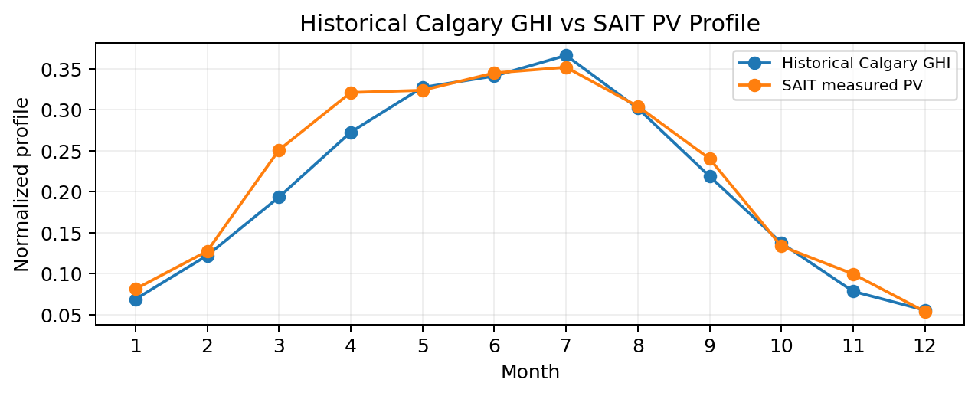
Figure 4. Supporting month-level view of the verified normalized Calgary GHI and SAIT PV profiles.
Interpretation boundary
r = 0.9686 supports strong similarity in the seasonal/diurnal profile. It is a climatological consistency check, not direct predictive model validation and not proof of timestamp-level accuracy.

9. Results Against Proposal Objectives
Objective / deliverable | Verified final result | Status
D1 - GHI prediction model | Random Forest test R² 0.9169; MAE 36.59; RMSE 69.54; all cities R² > 0.90 | Met for GHI prediction
D2 - City comparison dashboard | Power BI page "City Comparisons" uses the 23,040-row city-year-month-hour table | Met
D3 - Panel sizing / tilt optimization | 39°–42° optimized tilt; 10 kWp and 100 kWp annual yield + payback tables | Met
D4 - Seasonal irradiance heatmap | Power BI page "Seasonal heatmap" contains month-by-city matrix and line chart | Met
D5 - Long-term GHI trends | Linear regression + Mann-Kendall; Edmonton significant | Met
D6 - SAIT direct validation | No overlap; direct error/PR blocked; r = 0.9686 profile consistency check substituted | Method changed / partially met

9.1 Verified Power BI implementation
The current PBIX contains exactly 4 report pages: City Comparisons, Seasonal heatmap, Optimization & Payback, Trends & Sait. The main `powerbi_solar_dashboard` export contains 23,040 rows (4 cities × 20 years × 12 months × 24 hours) and 11 columns. The first two pages use this table for city/year/month/hour solar exploration. Optimization/Payback and Trends/SAIT use the specialized Python output tables directly.
Power BI performance mitigation
The proposal identified a risk that importing the full hourly dataset could slow Power BI. The final solution implements that mitigation by pre-aggregating the main report table in Python rather than requiring Power BI to process all 701,280 hourly rows [P2].

10. Changes from the Original Proposal
Original plan | Verified final implementation | Why it changed
CWEEDS 1998–2020 / 22 years | 1998–2017 / 20 years | Actual selected station files end in 2017
Predict hourly solar PV output | Random Forest predicts hourly GHI; PV annual yield is modeled separately from POA × capacity × PR | Final notebooks separate irradiance prediction from system-yield estimation
Features included sunshine minutes, sky condition, clear-sky index, rolling GHI and solar zenith | Final ML uses geography, temperature, dew point, wind, pressure, cyclical time and city dummies | Final cleaned/defensible feature set and leakage control
Hyperparameter tuning via cross-validation | Three RF configurations compared on fixed 2012–2014 validation set | Executed notebook uses chronological validation, not k-fold CV
Direct 2019 SAIT overlap validation + real PR | No overlap; month-hour normalized profile check instead | Supplied Calgary CWEEDS ends 2017
Separate −0.40%/°C temperature derating | Not separately modeled; final sizing uses PR = 0.80 | Executed sizing formula is POA × capacity × PR
Grid-emission factor / CO₂ avoidance assumption | No CO₂-avoidance output in final notebooks or PBIX | Not implemented in final analytical solution
Restrict SAIT validation to selected years due outages | Use all complete hours across 2019–2023, including valid parts of 2021/2022 | Quality filter at the hourly level is more precise than blanket year exclusion

11. Risk / Reward and Critical Thinking
Risk | Final control | Trade-off / reward
Coded/missing weather fields | Flag/code audit; incomplete fields excluded | Fewer features, stronger data integrity
Temporal leakage | Chronological train/validation/test split | More realistic out-of-time evaluation
Target leakage | DNI/DHI excluded from final ML predictors | Harder but more defensible GHI task
RF overfitting | Validation-based selection + untouched test + city-level metrics | Evidence of generalization
SAIT outages | Complete-hour filter | Less volume, higher-quality campus signal
No SAIT overlap | No fabricated direct metrics | Lower claim strength, higher methodological validity
Financial uncertainty | Best/base/worst payback scenarios | Avoids false precision
Power BI scale | 23,040-row pre-aggregated main table | Faster stakeholder report

11.1 Limitations and Reproducibility
- The four supplied CWEEDS files end in 2017, so post-2017 weather variability is outside this analysis.
- CWEEDS stations represent airport/regional conditions and may not reproduce every rooftop microclimate [P2].
- SAIT coverage is uneven. The campus result is a normalized profile comparison, not time-aligned validation.
- The PV/yield model is simplified: it uses optimized POA and PR = 0.80 and does not separately model the proposed temperature coefficient, degradation, financing, incentives, maintenance, inflation, tariff structure, LCOE or NPV.
- Random Forest feature importance describes the fitted model and should not be interpreted as causal effect.
- The low/high financial scenarios are sensitivity assumptions, not market forecasts.
Notebook / artifact | Verified role
01_data_cleaning.ipynb | CWEEDS + SAIT parsing, cleaning, unit conversion, quality audits
02_eda.ipynb | City/month/season/hour EDA, correlations, annual GHI, trend tests
03_feature_engineering.ipynb | Model table, cyclical features, one-hot city encoding, chronological masks
04_modeling.ipynb | Linear baseline, RF configurations, final test and city-level evaluation
05_sait_validation.ipynb | Coverage assessment and r = 0.9686 climatological consistency check
06_tilt_optimization.ipynb | pvlib POA simulation, tilt, PV sizing, payback and sensitivity
07_powerbi_exports.ipynb | 23,040-row Power BI main export
Capstone_Project.pbix | Four verified report pages using pre-aggregated Python outputs

12. References
[P1] Group 3. Deliverable 1: Mission Statement and Stakeholder Analysis. Solar Energy Potential Analysis Across Alberta.
[P2] Group 3. Deliverable 2: Project Scope Statement and Parameters (revised). SAIT Data Analytics Capstone, 2026.
[P3] Group 3. Deliverable 3: Written Proposal. Solar Energy Potential Analysis Across Alberta, 2026.
[R1] Environment and Climate Change Canada. (2023). Canadian Weather Energy and Engineering Datasets (CWEEDS). Government of Canada. Source listed in project proposal.
[R2] Natural Resources Canada. (2023). Canadian Weather Year for Energy Calculation (CWEC). Open Government Portal. Source listed in project scope.
[R3] Duffie, J. A., & Beckman, W. A. (2013). Solar Engineering of Thermal Processes (4th ed.). Wiley. Source used in project scope for the benchmark tilt relationship.
[R4] Gadiwan, A., & Shahbazi, M. (2019). Rooftop solar energy potential of Calgary. Schulich School of Engineering, University of Calgary. Source listed in project scope.
[R5] Environment and Climate Change Canada. (2023). National Inventory Report 1990–2021: Greenhouse Gas Sources and Sinks in Canada. Listed in project scope; the proposed emission-factor analysis was not implemented in the final solution.
[R6] Canada Energy Regulator. (2023). Provincial and Territorial Energy Profiles — Alberta. Source listed in project scope.
[R7] Southern Alberta Institute of Technology (SAIT). Campus solar generation monitoring data — Great Hall Building/GBTAC Carport and Rooftop PV systems [Dataset]. Provided to the capstone team.

